The Cole Land Transportation Museum in partnership with the family of dedicated long term employee and volunteer Cliff Vining, is pleased to announce the Cliff Vining Memorial Scholarship.
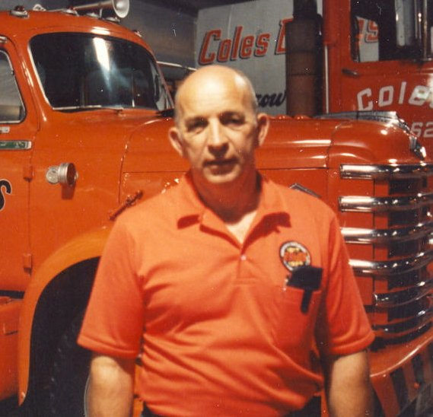
The purpose of this scholarship is to provide financial assistance to the children and/or grandchildren of current and former volunteers and employees of the Cole Land Transportation Museum or Coles Express, as well as young volunteers in pursuit of a post-secondary degree or post-secondary certification. This scholarship will serve as a means to introduce younger members of the community to the value of volunteering for a worthy organization, and provide much needed volunteer support for the Cole Land Transportation Museum.
To qualify for this scholarship, the applicant must:
- Be a volunteer at the museum and completed at least 25 hours of volunteer time.
- Already be accepted to a post-secondary educational or trade program.
- Have acceptable academic performance.
- Demonstrate financial need.
- Submit an application and essay regarding their future plans with a focus on how this scholarship will help them attain their goals.
The successful applicant will be awarded a monetary scholarship based on need and funds available in exchange for at least 25 additional hours of time volunteered at the museum during a weekly designated four (4) or eight (8) hour shift in one of the following positions: cashier, tour guide, curatorial assistant or office assistant.
The awarded funds will be deposited in the student’s school account at the beginning of the fall semester or at the beginning of their certification course. If the student fails to meet the standard for their course or certification, or fails to complete their obligated museum hours, no further scholarship will be awarded.
Cliff Vining was a loyal, dedicated, and talented employee and volunteer first with Coles Express, and then as a key volunteer during building of the museum and the securing of the artifacts that are one of a kind and special. A hard working man, Cliff’s family wants to reward those willing to put forth hard work and effort to not just improve themselves but also those around them.
For more information call the Cole Land Transportation Museum at (207)990-3600 or go to our website at www.colemuseum.org and click on the volunteer tab.

