Where’s Allie? (Hunt)

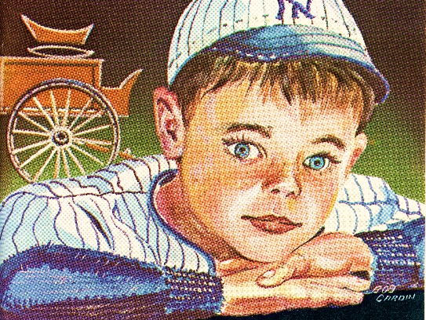
Albert J Cole, called Allie or A. J., was born in 1893 in Lowell, Maine. He left home at the very young age of 8 to make his way in the world.

Many of the artifacts in the Cole Land Transportation Museum can be associated with Allie and his adventures during his lifetime. See how many of the item listed in this brochure you can locate.

Look at this picture of young Allie Cole wearing his baseball suit (a cherished gift to this 8-year-old boy) which he wore wherever he went. Find this picture hidden with different artifacts around the museum. When you find a picture of “Allie” match the number to learn about his life and adventures. Non-readers can enjoy this game with the help of an adult to read the stories.

- Horse Bells:
When Allie harnessed up his teams of horses he more often than not put bells on them. They made a cheerful noise as the horses moved along.

- Clydesdale:
Allie Cole loved horses! He moved on from the West farm to the Prebles where he helped to care for the livestock. At one time he wanted to run away and join the circus so that he could always care for horses. Mrs. Preble talked him out of joining the circus.

- Chariots:
Allie may not have had much time to play with toys when he was young but he still knew how to have fun. After he had made a success of his business, he had these chariots built out of old parts and then held races at Bass Park in Bangor.

- Horse and Carriage Toy:
Allie started working at age 8 so he did not have time to play. This horse and carriage pull toy, given to him by his foster parents, the Prebles, was probably his only toy—ever!

- Carriage Robe:
Instead of joining the circus, Allie went to work in the livery stable in Enfield. His job was to care for the horses and also to drive salesmen who arrived by train to their local stops. He had a lap-robe like this which he prized very much given to him by an elderly lady. It helped keep him warm when he had to drive the wagon in cold weather.
- Jigger Wagon:
Allie also worked in the railroad freight house. Farmers and others would come to pick up heavy goods like molasses or nails in a wagon called a “jigger”. It sits low to the ground to make it easier to load and unload.

- Long Log Sled:
In the winter of 1920 Allie Cole worked hauling logs across Crystal Lake. He used a sled like this. Once the ice gave way but Allie was able to cut the horses loose from the sled and save them.

- Milk Cans:
When Allie first left home he stopped at the farm of Jim West. There he found work milking the eight cows! Milk was often stored in cans like these.

- Baggage Cart:
After Allie worked at the livery stable, he got a better job at Enfield Railroad Station as the baggage master. That meant that he loaded baggage on and off the trains. He met all the trains from 4:45 AM to 11:45 PM! That was a very long work day.

- Telegraph:
Because he began working at such a young age Allie did not get much formal schooling. His wife, Amy, who was a school teacher, helped him improve enough to be the back-up telegraph operator at the Enfield Station.

- Weathervane:
This weathervane of a running horse was located on the roof of the big barn where Allie Cole set up his freight business when it moved from Enfield to Bangor.

- Freight Wagon:
Allie Cole started his own freight company with two horses and a wagon. He carried the mail, merchandise for stores and even passengers.

How many did you find? _______

What else did you see in the Museum that might have been a part of Allie Cole’s life?
________________________________________________________________________

________________________________________________________________________

